Help: *R* = 8.314 J mol1 K1; *NA* = 6.022x1023; *h* = 6.626x1034 J sec; c=2.998x108 m/sec;

*e* = 1.602x1019 C; *R*H = 3.290x1015 sec1; *m*p/*m*e = 1836; 1 kcal = 4.184 kJ.

For light of wavelength 1240 nm, the photon energy is 1.00 eV.

Heat capacity: water 1 cal/g∙K, ice 0.5 cal/g∙K; enthalpy of melting of ice = 80 cal/g, enthalpy of evaporation of water = 540 cal/g.

For phase change and chemical reaction, you may assume Ho and So do not depend on T.

**(11)** Estimate the de Broglie wavelength for the following objects. You may use the typical or averaged value if necessary.

**(11a)** A dust particle (assume 1 mg) at 1 m/s speed.

$$p=mv=\frac{1}{1000×100}×1={10}^{-5} \left(kg∙m/s\right) \\ p=\frac{h}{λ}=\frac{6.626×{10}^{-34}}{λ}={10}^{-5}, λ=6.626×{10}^{-29} (m)$$

**(11b)** A He atom at 300 K.

$$He atom mass=4 g/{mole}=\frac{0.004}{6.02×{10}^{23}}g/{atom}=6.645×{10}^{-27}g/{atom} \\ Energy=\frac{3}{2}kT=\frac{3}{2}×\frac{8.3145}{6.02×{10}^{23}} ×300=6.215×{10}^{-21} \left(J\right) \\ Momentum= \sqrt{2mE}=\sqrt{2×6.645×{10}^{-27}×6.215×{10}^{-21}}=9.088×{10}^{-24} \left(kg∙m/s\right)=\frac{h}{λ} \\ λ=7.29×{10}^{-11}\left(m\right)=0.729 Å$$

**(11c)** An electron of 1 eV energy.

$$E=1eV=1.602×{10}^{-19} \left(J\right) \\ p=\sqrt{2mE}=\sqrt{2×9.11×{10}^{-31}×1.602×{10}^{-19}}=5.402×{10}^{-25} \left(kg∙m/s\right)=\frac{h}{λ} \\ λ=1.226×{10}^{-9} \left(m\right)=12.26 \left(Å\right)$$

**(11d)** A potassium atom at 1 K (micro Kelvin).

$$K atom mass=30.9 g/{mole}=\frac{0.0309}{6.02×{10}^{23}} g/{atom}=5.133×{10}^{-26} g/{atom}$$

$$Energy=\frac{3}{2}kT=\frac{3}{2}×\frac{8.3145}{6.02×{10}^{23}} ×{10}^{-6}=2.072×{10}^{-29} \left(J\right) \\ Momentum= \sqrt{2mE}=\sqrt{2×5.133×{10}^{-26}×2.072×{10}^{-29}}=1.458×{10}^{-27} \left(kg∙m/s\right)=\frac{h}{λ} \\ λ=4.543×{10}^{-7}\left(m\right)=454.3 (nm)$$

**(12)** For particle-in-a-box system, if the mass is 1 amu (same as that of H atom) and the box size is 1 Å.

**(12a)** Deduce the translational energy of the ground state. (convert your answer to both units of eV and cm1)

**(12b)** Deduce the energy gap between the ground state and the first excited state. (convert your answer to both units of eV and cm1)

**(12c)** Plot the probability densities of the ground state and the second excited state. Remember to show the correct units for the x-axis and y-axis labels.

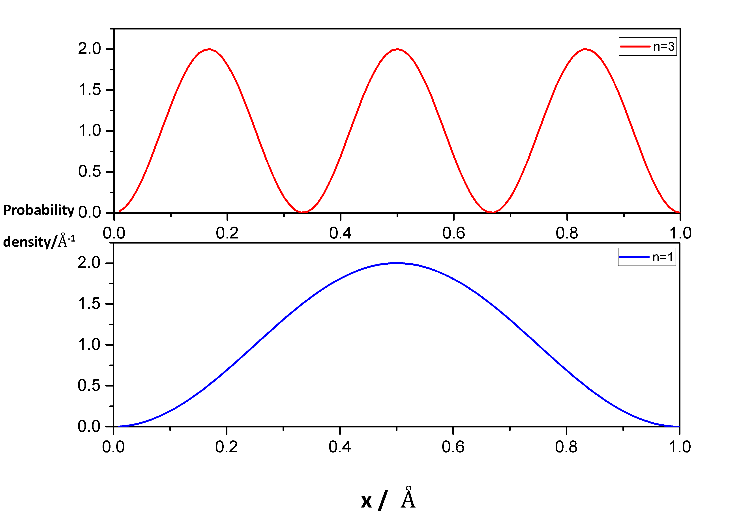

**(12d)** Estimate the probabilities of finding the particle near the center of the box within ± 0.01 Å (i.e., 0.49 L – 0.51 L) for the ground state and the second excited state. (error < 5%)

The wavefunction of particle-in-a-box system is solved by Schrodinger equation.

$$ψ=\sqrt{\frac{2}{L}}\sin{(\frac{nπ}{L}x)}$$

The wavefunction ($ψ$) must satisfy $\int{ψ^{*}}ψdx=1$, which means the probability in the whole space is equal to one. So we need this term $\sqrt{\frac{2}{L}}$.

ground state, n=1

$$\int_{0.49L}^{0.51L}{ψ*ψdx=}\frac{2}{L}\int_{0.49L}^{0.51L}{\sin^{2}\left(\frac{π}{L}x\right)dx=}\frac{2}{L}×\frac{1}{2}\int_{0.49L}^{0.51L}{[1-\cos{(2\frac{π}{L}x)]}dx}$$

$$=\frac{1}{L}\left(0.51L-0.49L\right)-\frac{1}{L}×\frac{L}{2π}{\left[\sin\left(2\frac{π}{L}x\right)\right]}_{0.49L}^{0.51L}=0.03999$$

second excited state, n=3

$$\int_{0.49L}^{0.51L}{ψ*ψdx=}\frac{2}{L}\int_{0.49L}^{0.51L}{\sin^{2}\left(\frac{3π}{L}x\right)dx=}\frac{2}{L}×\frac{1}{2}\int_{0.49L}^{0.51L}{[1-\cos{(2×\frac{3π}{L}x)]}dx}$$

$$=\frac{1}{L}\left(0.51L-0.49L\right)-\frac{1}{L}×\frac{L}{6π}{\left[\sin\left(6\frac{π}{L}x\right)\right]}_{0.49L}^{0.51L}=0.03988$$

**(13a)** Analyze the IR absorption spectrum of HCl(g) (as below. From Wikimedia Commons) and obtain the rotational constants (*B’* and *B”*) and vibrational frequency (**0-1) of HCl molecule. Compare your results with those from the literature.



Peak position: $ΔE=ΔE_{vibration}+ΔE_{Rotation}=hc\left[ν_{1-0}+B^{'}J^{'}\left(J^{'}+1\right)-B“\text{J}”\left(J”+1\right)\right]$

3 variables --> choose 3 peaks to solve $ν_{1-0},B^{'},B“$

Here choose 2865, 2906, 2926 cm-1

|  |  |  |  |  |
| --- | --- | --- | --- | --- |
| No. | Peak (cm-1) | J’ | J” | equation |
| Eq.1 | 2865 | 0 | 1 | $$ν_{1-0}-B“×1×\left(1+1\right)$$ |
| Eq.2 | 2906 | 1 | 0 | $$ν_{1-0}+B'×1×\left(1+1\right)$$ |
| Eq.3 | 2926 | 2 | 1 | $$ν_{1-0}+B'×2×\left(2+1\right)-B“×1×\left(1+1\right)$$ |

Eq.3-Eq.1: $6B^{'}=61 {cm}^{-1}, B^{'}=10 {cm}^{-1}$

Insert to Eq.2: $2906 {cm}^{-1}=ν_{1-0}+2×B^{'}=ν_{1-0}+2×10 cm^{-1}, ν_{1-0}=2886 cm^{-1}$

Insert to Eq.1: $2865 {cm}^{-1}=ν_{1-0}-2B”=2886 {cm}^{-1}-2B", B"=10.5 {cm}^{-1}$

**(13b)** Using the value of *B”*, estimate the bond length of HCl and compare your answer with that from literature.

$$I=\frac{h}{8π^{2}cB}=\frac{6.626×{10}^{-34}J∙s}{8π^{2}×2.998×{10}^{8}\frac{m}{s}×1050m^{-1} }=2.666×{10}^{-47} kg∙m^{2}$$

For a diatomic molecule,

For H35Cl,

**(14a)** Why N2 and O2 have no IR absorption?

Because there is no dipole moment change when a homonuclear diatomic molecule vibrating.

**(14b)** Which vibrational modes of CO2 are IR active? Which is IR inactive?

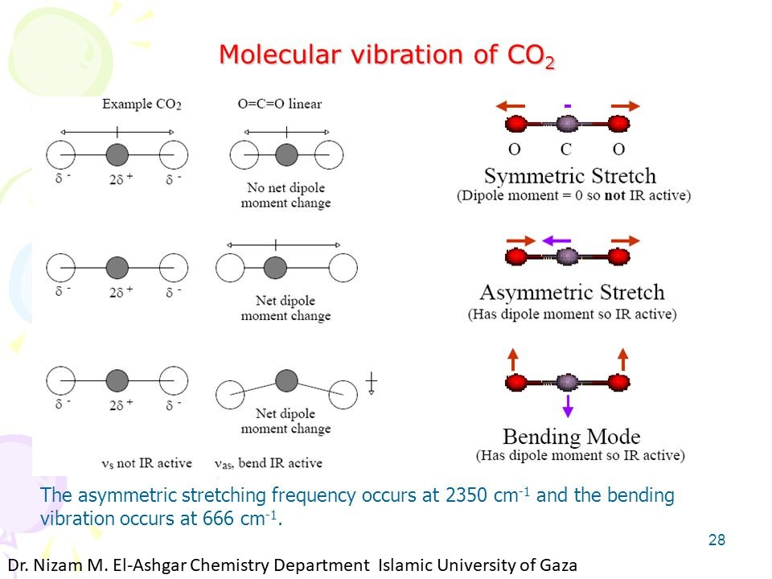

**(15a)** List the disadvantages of aluminum alloy.

太輕、太軟、強度不夠、不容易焊接、比較貴

**(15b)** What is Anodized Aluminum Oxide? Where can you see it?

See : “Chemistry in Life_0429.pptx” uploaded on ceiba

**(16)** Glycine is an amino acid which has both acidic functional group (COOH) and basic functional group (NH2).

**(16a)** Find the values of *K*a1 and *K*a2. (from Wiki or …)

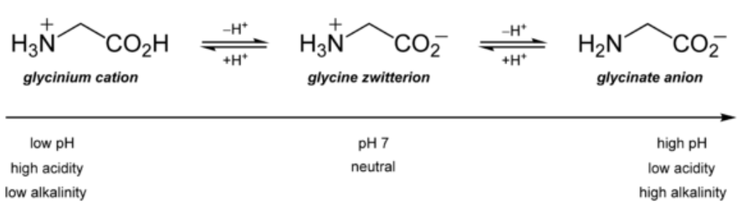

pKa1 = 2.34

Ka1 = 102.34

= 4.57 x 103

pKa2 = 9.6

Ka2 = 109.6

= 2.51 x 10

**(16b)** Plot the concentration profiles of the related species, [NH3+CH2COOH], [NH2CH2COOH], and [NH2CH2COO], for the system of 0.1 M glycine aqueous solution as a function of pH.

Note: An amino acid changes its charged state (+1, neutral, or -1) depending on the pH value. This property plays a very important role in biology and bioanalysis.

|  |  |  |  |
| --- | --- | --- | --- |
| pH | [NH3CH2COOH]  / M | [NH3CH2COO] / M | [NH2CH2COO] / M |
| 1.34 | 0.091 | 0.009 | 0 |
| 2.34 | 0.05 | 0.05 | 0 |
| 3.34 | 0.009 | 0.091 | 0 |
| 8.6 | 0 | 0.091 | 0.009 |
| 9.6 | 0 | 0.05 | 0.05 |
| 10.6 | 0 | 0.009 | 0.091 |

$$K_{a2}=\frac{\left[NH_{2}-COO^{-}\right][H^{+}]}{\left[{NH}_{3}^{+}-COO^{-}\right]}$$

$$0.1M=\left[{NH}_{3}^{+}-COOH\right]+\left[{NH}_{3}^{+}-COO^{-}\right]+\left[NH_{2}-COO^{-}\right] \\ =\frac{\left[{NH}_{3}^{+}-COO^{-}\right]\left[H^{+}\right]}{K_{a1}}+\left[{NH}_{3}^{+}-COO^{-}\right]+\frac{K_{a2}\left[{NH}_{3}^{+}-COO^{-}\right]}{\left[H^{+}\right]} \\ =\left(\frac{\left[H^{+}\right]}{K_{a1}}+1+\frac{K_{a2}}{\left[H^{+}\right]}\right)\left[{NH}_{3}^{+}-COO^{-}\right] (\left[H^{+}\right]={10}^{-pH})$$

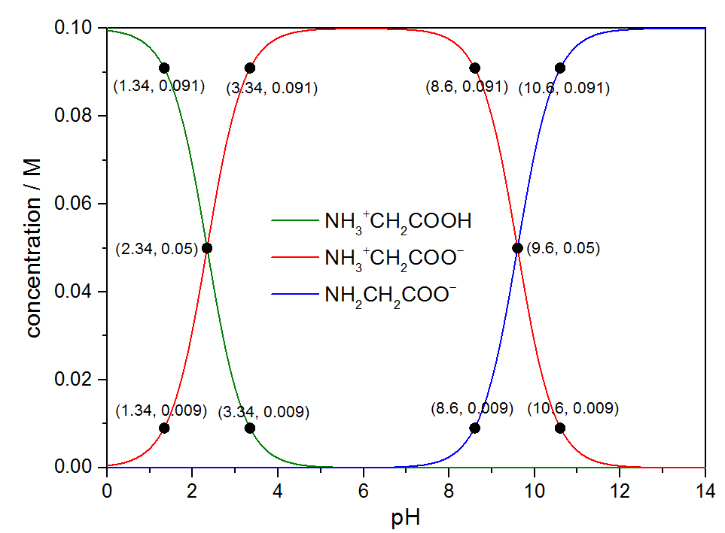

需標出pH = pKa, pH = pKa ± 1 的點

**(17)** Draw the schematic structures of PE, PP, PS, PVC, and Teflon.

|  |  |  |  |  |  |
| --- | --- | --- | --- | --- | --- |
| Abbr. | PE | PP | PS | PVC | Teflon® |
| Full name | Polyethylene | Polypropylene | Polystyrene | Polyvinyl chloride |  |
| Structure |  |  |  |  |  |

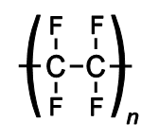

**(18a)** Most pure metals are quite reactive towards oxygen. What are the exceptions?

Ag, Pt, Au …. etc.

**(18b)** Why it is not often to see a piece of metal burns?

1. 大部分金屬氧化時會在表面形成緻密氧化層，保護內部金屬不氧化
2. 金屬易導熱，點火時熱量容易分散，難以達到燃點。
3. 融/沸點高(次要原因): 大部分可燃物(汽油、蠟燭等)，是先汽化、再以氣相與氧氣反應，因為氣態的可燃物可與氧氣均勻混和，增加反應速率。